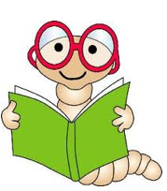

What is the author *telling* me here?

Are there any hard or important *words*?

What does the author want me to *understand*?

How does the author play with language to add to the *meaning*?

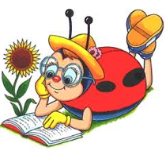

What is the author *telling* me here?

Are there any hard or important *words*?

What does the author want me to *understand*?

How does the author play with language to add to the *meaning*?